INSERT BUSINESS NAME HERE
INSERT BUSINESS LOGO OR BUSINESS IMAGE BELOW (LOGO OR PHOTO)
INSERT BUSINESS WHATSAPP NUMBER HERE
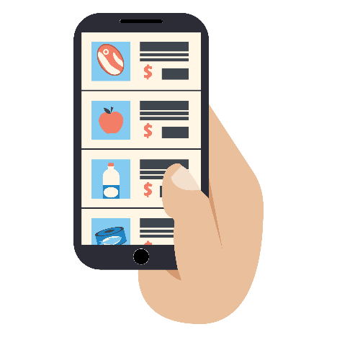
THANK YOU FOR SUPPORTING AND HELPING LOCAL SMALL BUSINESSES!
THROUGH COMMUNICATION WITH OUR WHATSAPP NUMBER, WE OFFER:
- WhatsApp orders
- Home delivery
- Curbside store pick-up
- Product catalogs and daily promotions

