INSERT BUSINESS NAME HERE
INSERT BUSINESS IMAGE ABOVE (LOGO OR PHOTO)
INSERT BUSINESS WHATSAPP NUMBER HERE
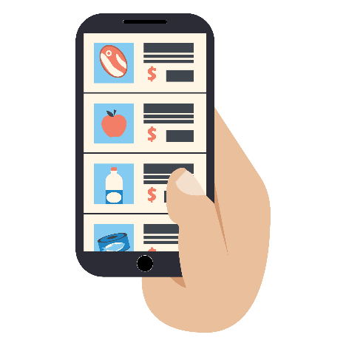
THANK YOU FOR SUPPORTING LOCAL, SMALL BUSINESSES!
THROUGH WHATSAPP COMMUNICATION, WE OFFER:
- WhatsApp orders
- Home delivery
- Curbside store pick-up
- Product catalogs and updated promotions

